Homework 5

Assignment: https://github.com/asaxe26/f25-hw5

Primary Observations
Run the template as it is:
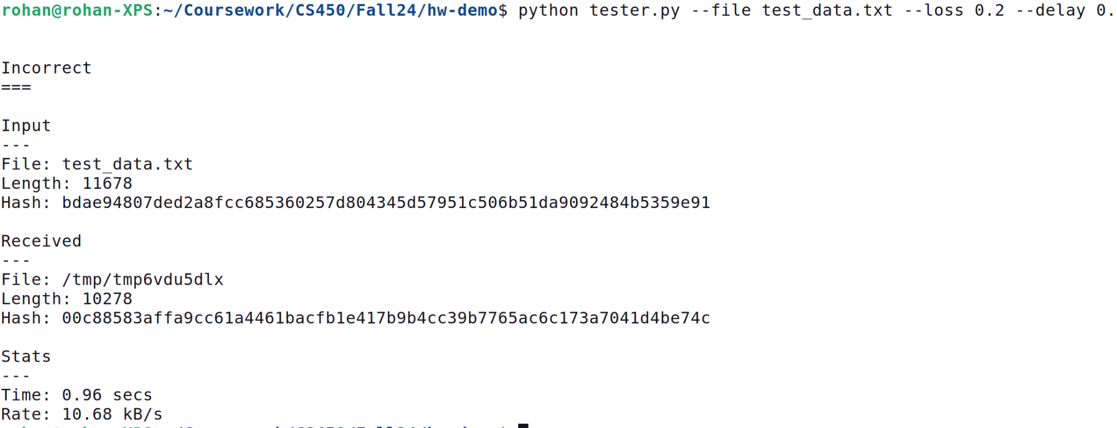
- Data received < Data Sent
- A hash computed on received data is different

Requirements
- An additional layer of the protocol in the application layer
- Need reliability to handle packet losses: Sequence number and respective Acks
- Packets could be late, how to differentiate loss from delay: Dynamic Timeout based on RTT observed

Simple Approach
- Do not use AI tools and I will be checking for Plagiarism. This is a very simple assignment.
- Application layer protocol: There are three types of packets
  - Data Packets
  - Acknowledgments
  - FIN
Additionally, we want to identify every single packet uniquely thus we will require sequence numbers.

- Note that the Application layer protocol consumes a few bytes in every packet, so the actual data length per packet is reduced. Divide entire data into chunks with sequence numbers.

- Set the socket timeout to identify the losses. Send the packet and wait for the receiver's acknowledgement. Make provision for retransmissions.

- On receiving the acknowledgment, measure RTT and calculate a new timeout value.

- The final packet is FIN to indicate the end of the data transfer

Expectation
This solution is not optimized
